Nutrition and Wellness Study Guide – Test #1

- What is the definition of nutrition?
- What is the definition of wellness?
- What are your 3 wellness goals? How are you doing accomplishing these goals?

- What is the My Plate and how do I use it?
https://tinyurl.com/ybcjcku7

*Be able to draw and label the My Plate
*Know about each food group on the My Plate
https://www.choosemyplate.gov/quiz

*Know numbers of calories you need per day
*Know the amount of each food group from the My Plate you should eat per day.

- What are your 3 nutrition goals? How are you doing accomplishing these goals?

- What are the 6 essential nutrients?
https://tinyurl.com/y8n9uvnj

https://tinyurl.com/y8tmcc2q

- What is a food label and how can you read and understand a food label/ingredients list?
https://tinyurl.com/yaxfwyto

- How do you use a food label to figure out the numbers of calories coming from the following:
*carbs (1 gram = 4 calories)
*proteins (1 gram = 4 calories)
*fats (1 gram = 9 calories)
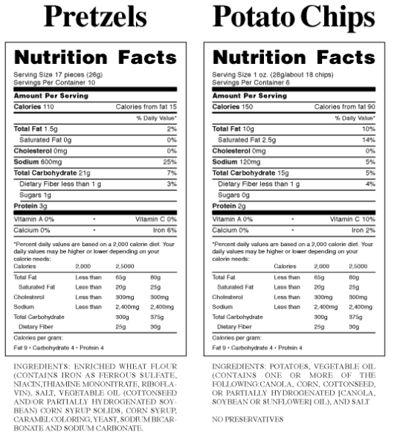
Evaluating Food Labels
1. What is the serving size (in grams) for each snack choice?
a. Pretzels = __________ grams
b. Chips = _______ grams
2. How many calories are in each snack choice for 1 serving?
a. Pretzels= _________ calories
b. Chips = _____________ calories
3. Calculate the amount of calories that come from carbohydrates in each snack food.
a. Pretzels = _________ calories
b. Chips = __________ calories
4. Calculate the amount of calories that come from protein in each snack food.
a. Pretzels = _________ calories
b. Chips = __________ calories
4. Calculate the amount of calories that come from fat in each snack food.
a. Pretzels = _________ calories
b. Chips = __________ calories
5. In your opinion, which snack food is the better choice for an after school snack? WHY?

