How Much Salt (NaCl) is That ? - Lab Jobs
Head Scientist – Weighs/measures the salt sample
Assistant Scientist - Helps head scientist, make sure all samples are bagged and labeled correctly
Lab Statistician – Completes the mathematics equation for the sample to be weighted/measured and reports the amount to the head scientist
Lab Manager – Keeps lab area and equipment clean and places samples in the correct place. Makes sure all lab participants are following safety rules and are properly dressed for lab work (lab coat on and tied up, gloves on, protective eye wear on)
Milligrams of Sodium to Milligrams & Grams of Salt
1 mg x 2.5 = __________ mg salt /1000 ______g salt
40 mg x 2.5 = _________ mg salt /1000 ______g salt
135mg x 2.5 = ________ mg salt /1000 ______g salt
190mg x 2.5 = ________ mg salt /1000 ______g salt
270mg x 2.5 = _______ mg salt /1000 _______g salt
290mg x 2.5 = _______ mg salt /1000 _______g salt
480mg x 2.5 = _______ mg salt /1000 _______g salt
490mg x 2.5 = _______ mg salt /1000 _______g salt
677mg x 2.5 = _______ mg salt /1000 _______g salt
1,500mg x 2.5 = ______ mg salt/1000 _______g salt
> 2,300mg x 2.5 = ______ mg salt/1000 _____g salt
~ 3,440mg x 2.5 = _______ mg salt /1000 _______g salt
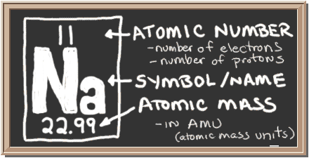
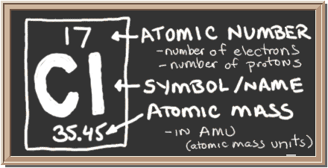
How to Calculate Salt (NaCl) from Sodium
Background Info
Some chemistry background and math calculations will be needed to determine the amount of salt in the food. Your students can refer to the Periodic Table of Elements to learn that the atomic mass of sodium (Na) is 23 and of chlorine (Cl) is 35.5. The molecular mass of sodium chloride (NaCl), therefore, is 58.5. Of this total mass, 0.40 or 40% is sodium (23 divided by 58.5). To calculate the amount of salt in a food, divide the mg of sodium by 0.40. For example, if the food contains 55 mg of sodium, then 55mg divided by 0.40 equals 138 mg of salt.
Dietary Guidelines for Americans
2015-2022
- Follow a healthy eating pattern across the lifespan.
- Focus on variety, nutrient density, and amount.
- Limit calories from added sugars and saturated fats and reduce sodium intake.
- Shift to healthier food and beverage choices.
- Support healthy eating patterns for all.

